# 1507_esb_logo_1_1.eps

# ESB Newsletter October 26, 2022

# New website | Call for nominations ESB Awards 2023 | Education Awards 2023 | 2023 Biomaterials Science Lectureship Award | ESB2029 Bids

Dear members of the European Society for Biomaterials,

After the amazing ESB Conference we had in Bordeaux, where our hosts provided us with 5 days of excellent science and many opportunities to get together, the preparation of ESB2023 is now in full swing. We will keep you posted but for all the details and latest updates, please check the conference website [here](https://esb2023.org/) and [twitter](https://twitter.com/ESB2023) account.

As promised during our General Assembly, we have now launched the reworked ESB website! This task was led by Sandra van Vlierberghe, our Communication Officer, and involved all members of the council. We aimed at renovating the layout but above all, provide new functionalities to our members, among which we draw your attention to the “ESB Member Highlight” section and the possibility to search for colleagues’ profiles. In our November newsletter, we will send further information highlighting the new features of our website.

In the meantime, we remind you of all the coming deadlines.

Please do not miss the opportunity to nominate a colleague for one of our four prestigious awards: the [**George Winter Award**](https://www.esbiomaterials.eu/cms/content/george-winter-award), the [**Jean Leray Award**](https://www.esbiomaterials.eu/cms/content/jean-leray-award), the [**Klaas de Groot Award**](https://www.esbiomaterials.eu/cms/content/klaas-de-groot-award) and the [**International Award**](https://www.esbiomaterials.eu/cms/content/international-award). The deadline for nominations by ESB members in good standing is **November 30, 2022**. For further information regarding the awards, eligibility criteria and nomination process, please visit our website [here](https://www.esbiomaterials.eu/).

In addition to these scientific achievement awards, we remind you of the new deadlines for application for the [**Racquel LeGeros Award**](https://www.esbiomaterials.eu/cms/content/racquel-legros-awards) - **November 30, 2022** and **May 31, 2023**. This award is given to two graduate students per year who would like to pursue their research in International or European academic laboratories or companies dedicated to biomaterials and regenerative medicine, with the aim to increase their knowledge in a specific topic and/or a technology. The application deadline for the [**Julia Polak European Doctoral Awards**](https://www.esbiomaterials.eu/cms/content/eda-julia-polak) continues to be on **January 31, 2023**. For more information, please visit our website.

The call for nominations for the **2023 Biomaterials Science Lectureship Award**, the official journal of the ESB has also been announced. This annual award was established in 2014 to honor an early-stage career scientist who has made a significant contribution to the biomaterials field. The recipient of the award will be asked to present a lecture at our next year’s annual ESB conference in Davos, where they will also be presented with the award. The Biomaterials Science Editorial Office will provide financial support to the recipient for travel and accommodation costs. The recipient will also be asked to contribute a research article to the journal and will have their work showcased free of charge on the front cover of the issue in which their article is published. The article would be subject to the normal peer review standards of the journal. More information can be found on the Biomaterials Science [blog](https://blogs.rsc.org/bm/2022/10/03/biomaterials-science-lectureship-2023-nominations-now-open/?doing_wp_cron=1665398683.0566430091857910156250) and [Twitter](https://twitter.com/BioMaterSci/status/1576894112904740864). The deadline for the nominations is December 31, 2022.

Finally, we invite **bids for the organisation of the 37th Annual Meeting** of our society to be held in **2029**. More information about the organisation of a conference can be found [here](https://www.esbiomaterials.eu/cms/content/hosting-esb). The deadline for bid submission is also on **January 31, 2024**.

Kindest regards,

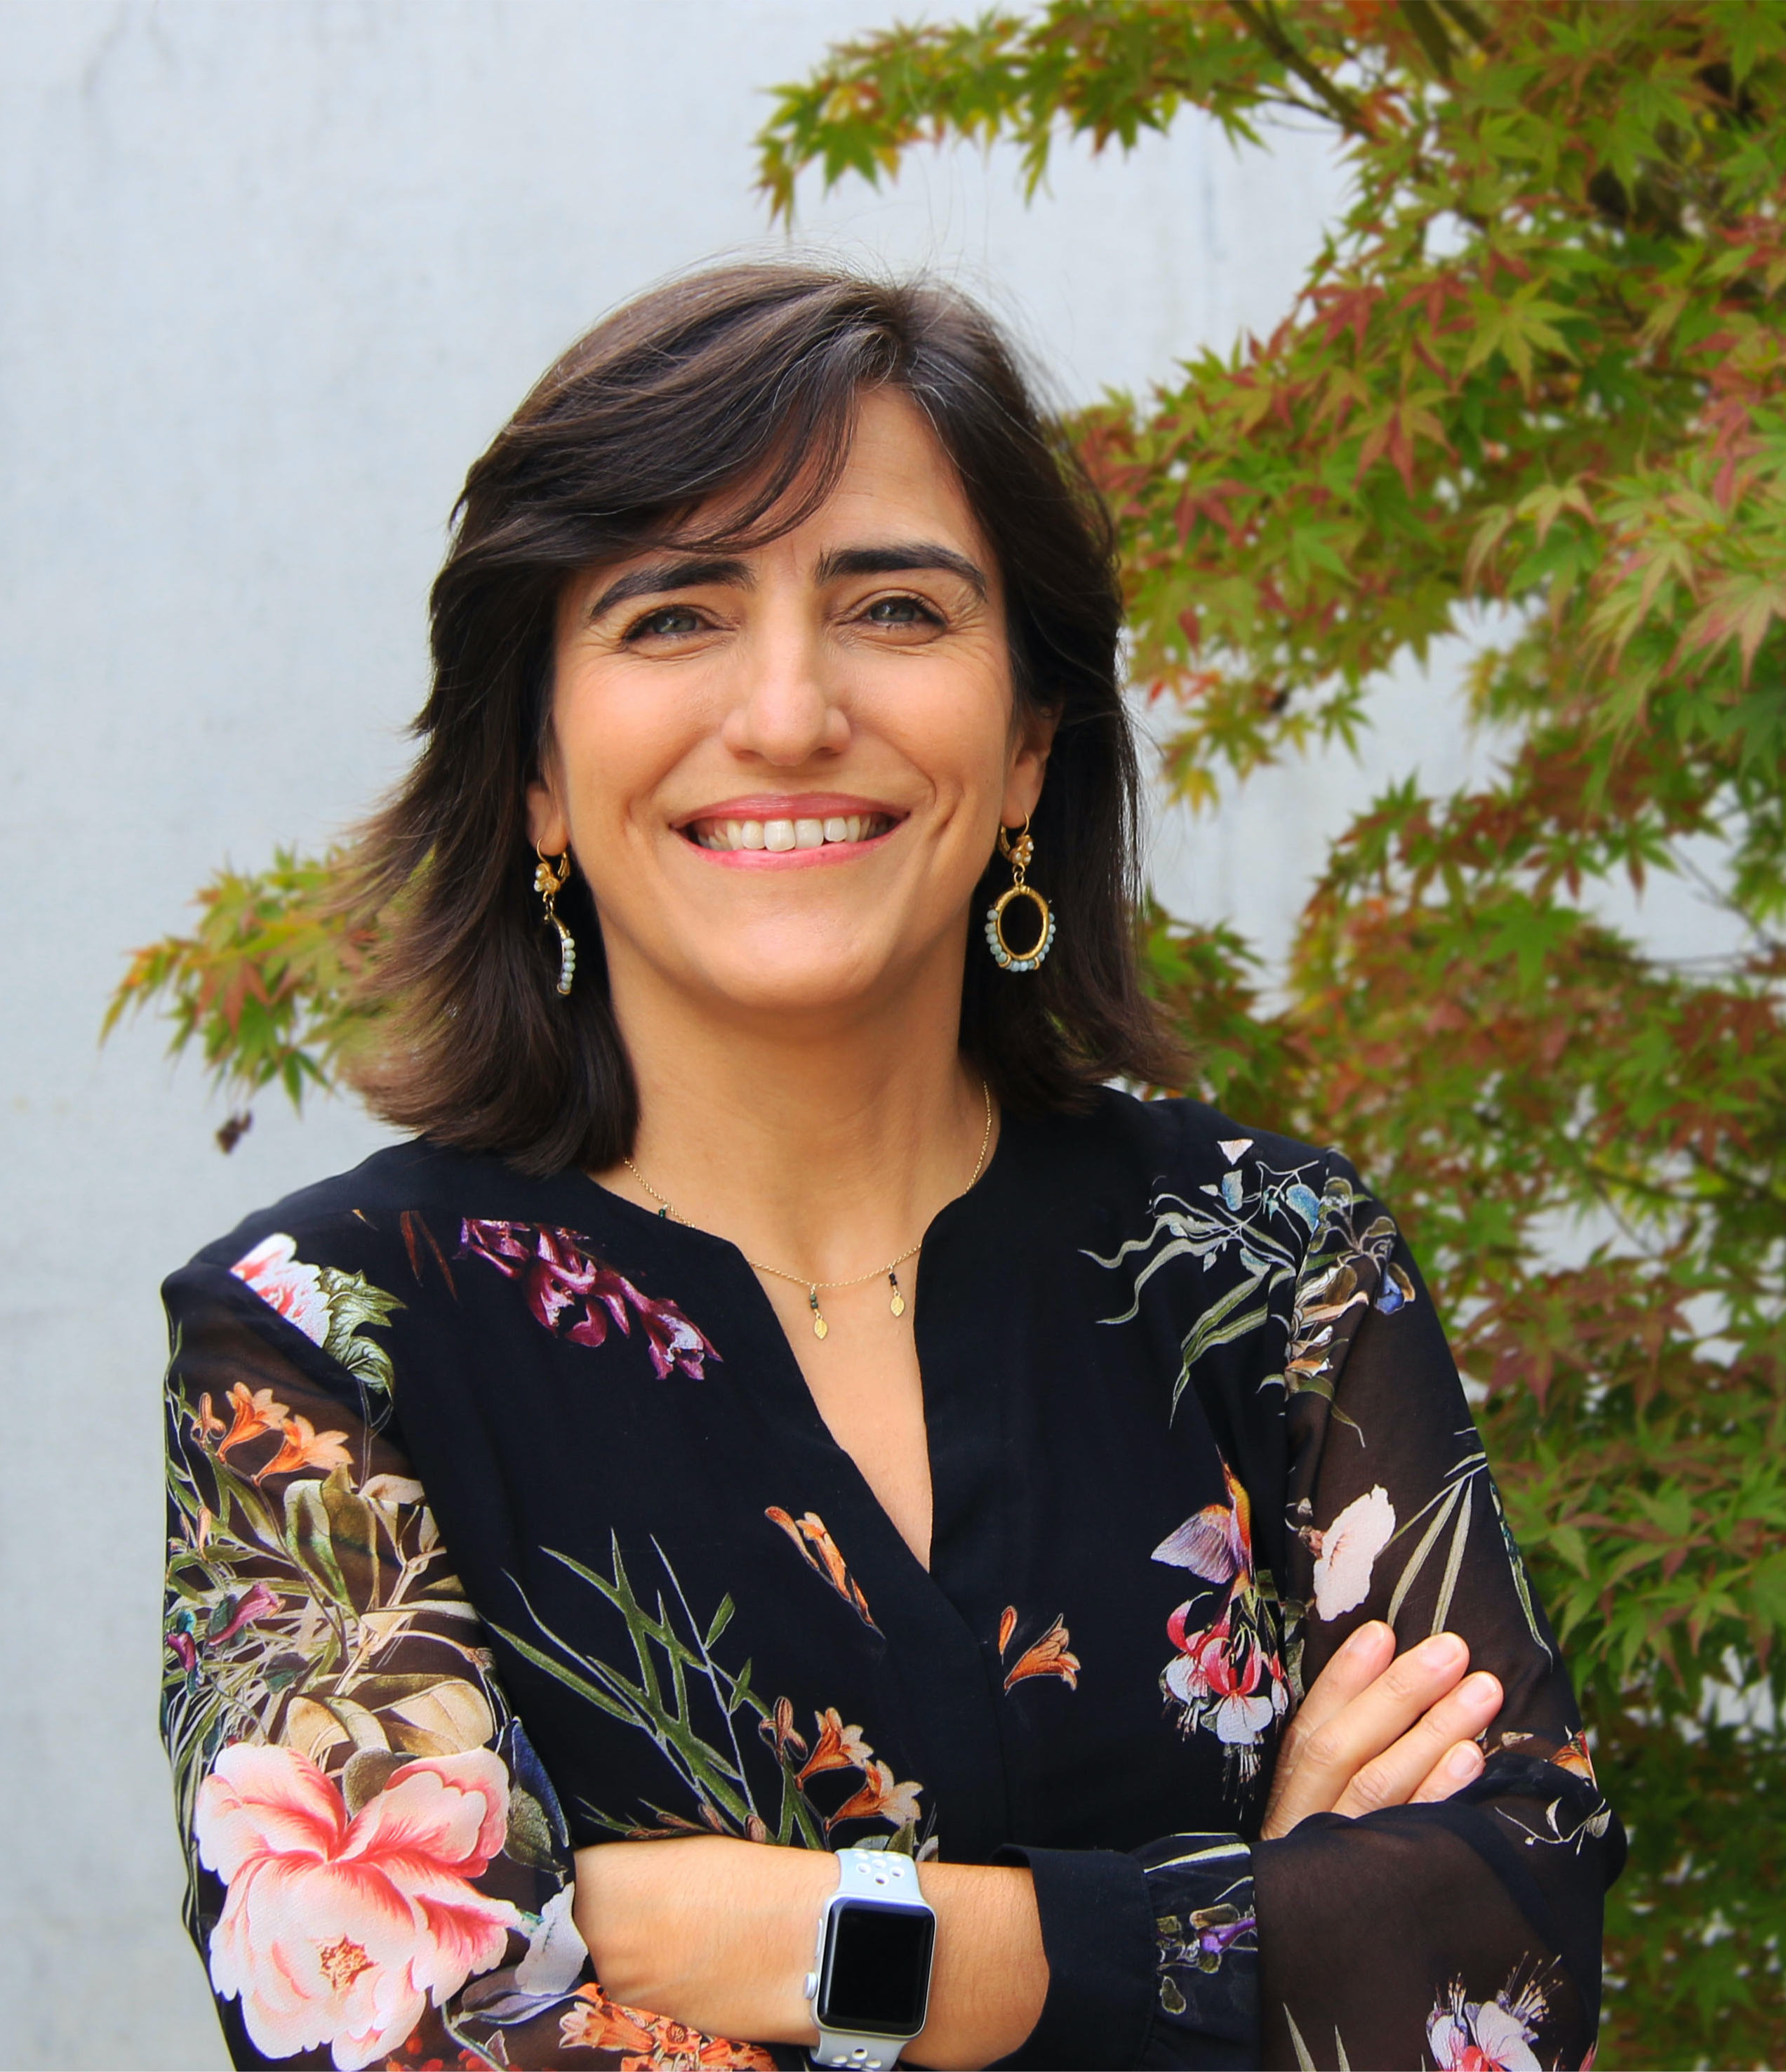

*Ana Paula Pêgo, President*

*(on behalf of the ESB Council)*